**Lab Exercise 2**– Terraform AWS Provider and IAM User Setting

Prerequisites: Terraform Installed: Make sure you have Terraform installed on your machine. Follow the official installation guide if needed. AWS Credentials: Ensure you have AWS credentials (Access Key ID and Secret Access Key) configured. You can set them up using the AWS CLI or by setting environment variables.

Exercise Steps:

**Step 1: Create a New Directory**:

Create a new directory for your Terraform configuration:

mkdir aws-terraform-demo

cd aws-terraform-demo

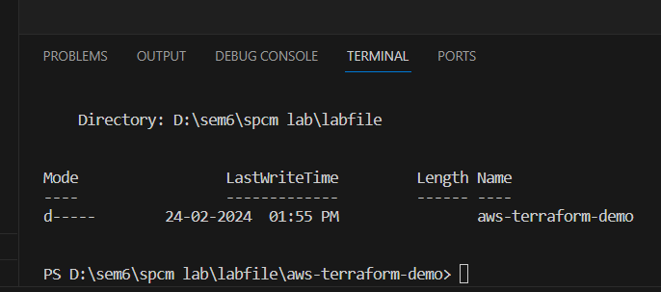

Step 2: Create Terraform Configuration File (main.tf): Create a file named main.tf with the following content:

